

**Birla Institute of Technology & Science, Pilani**

**Work Integrated Learning Programmes Division**

**M.Tech( Software Systems ) at Wipro Technologies (WASE)**

**Software Engineering Assignment**

Submitted By,

**Name : Jenetta Jose**

**Reg No. : 2019WA15719**

**Course Number : SSWTZC343**

**Date : 27th Aug 2021**

**Lab Exercise 1**:

**Ques 1**

**Online Railway Reservation**

The Indian Railways (IR) carries about 5.5 Lakhs passengers in reserved accommodation every day. The computerized Passenger Reservation System(PRS) facilities the booking and cancellation of tickets from any of the 4000 terminals that is PRS booking window all over the countries. These tickets can be booked or cancelled for journeys commencing in any part of India and ending in any other part, with travel time as long as 72hours and distance up to several thousand kilometers.

With the help of online booking people can book their tickets online through internet, sitting in their home by a single click of mouse. Using their credit cards people can easily get their tickets done within minutes.

Users will be able to search the train availability, the exact fare, the arrival and departure time of the train and they can also book the ticket by using the debit, credit or master card and after booking the ticket if the user want to cancel it they can easily do it also.

Railway passengers frequently need to know about their ticket reservation status, ticket availability on a particular train or for a place, train arrival or departure details, special trains etc. Customer information centers are the railway stations are unable to serve such queries at peak periods.

The online railway ticket reservation system aims to develop a web application which aims at providing train details, trains availability, as well as the facility to book ticket in online for customers. The application was to be divided into two parts namely the user part, and the administrator part.

The users are required to register on the server for getting access to the database and query result retrieval. Upon registration completion, each user has an account which is essentially referred to as the view level of the customer. The account contains comprehensive information of the user entered during the registration and allows the user to access their past reservations, cancellations, enquire about trains and train schedule, seat availability and make a fresh reservations. The user will also be able to update their account details, etc

The master user of this system is the Railway administrator who can login using a master password and once a user is authenticated as the admin, he/she can access and modify information stored in the database of this system. This includes adding and updating of train, station, train routes and also managing the user and passenger details.

The customers are privileged with the following services:

1. Register as a customer by providing certain personal details.
2. Make fresh reservations and book one or more (limited to 3 seats per ticket) seats.
3. View past booking and can even do cancellation of booked ticket.
4. See trains between a pair of stations, check seat availability in trains and get the fare details.

Administrator is privileged with the following services:

1. Login as the master user using a master password.
2. Add train, station and route.
3. See user and passenger details and can even delete their profiles after which the user will not be able to login to the system as a user.

The systems security has been kept into consideration well. The database of the system cannot be accessed by any user either admin or customer without being authenticated by correct username and password. The password set can also be modified and in case if the user forgets the password, it can be recovered by giving a correct answer to a security question.

**Limitations of system:**

1. **Data Redundancy** : It means that same data fields appear in different files and often in different formats. In manual system, it poses quite a big problem because the data has to be maintained in large volumes but in our system this problem can be overcome by providing the condition that if the data entered is duplicate, it will not be entered, otherwise , updating will take place.
2. **Difficult in accessing the data** : In manual system, searching information is time consuming but in our system any information can be accessed by providing the primary key.
3. **Unsatisfactory security measures**: In manual system, no security measures were provided but in this system, password security has been provided. The person can access the system by providing the correct password otherwise he is denied the access.

**The most exciting feature of the website that might be its selling point**.

1. **Searching of the trains is so easy**: It is easy to search for the wished train code, train number are there, you do not need to remember those, you just have to mention source and destination.
2. **Provides fare tables for passenger**: A fare table is already there so that passengers can know the specific price of their ticket. And as it is stored there the amount cannot wrong.
3. **Reduce the possibility to make mistake**: Due to excessive amount of work the employers tend to do mistakes by manual form. Here the chance of mistake is minimum.
4. **Reservation can be done very easily**: The overall method is very easy and based on few steps. No huge amount of knowledge is needed to complete the task.

**The most important feature of the website**.

1. Searching of data is easy.
2. Passengers don’t have to wait for a long time.
3. Information is accurate.
4. It is a fast process.
5. Data efficiency is more.

**Ques 2:**

**The Software Requirement Specification for Railway Reservation System is given as follows:**

1. **Introduction**
   1. **Purpose**

The purpose of Railway Reservation System is to create Reservation, cancel reservation, viewing train information, Viewing Reservation Details, Updating Train information, Updating Reservation Details and Generate Reports.

* 1. **Document Conventions**

Reservation Clerk is a person to create and cancel reservation by entering Login Password. Manager is a person who updates the Train Information by entering his own Password. The system can handle only reservation and train details efficiently ad it doesn’t contain other details about the railway administration. The main purpose of this system is:

1. Creating Reservation
2. Cancel reservation
3. View reservation status
4. View train schedule
5. Generating reports
6. Update train schedule
7. Update reservation details.

The Seats of Reservation cannot be more than the seats of Train at that date. This is a constraint that has to be followed by the Clerk when he creates the Reservation. For that purpose he wants to check the seats remaining present in the Train.

The scope of this system in creating Reservation is that, from any Railway Station we can Create Reservation, which is updated automatically in all the stations. Hence, there is no confusion to the Reservation Clerk in all the stations to create the Reservation. This can be possible by maintaining Global Database. Clerks present at different stations can access the global database and the clerks can easily understand the remaining reservation seats. It provides the ability to create reservation from different places for a train.

The system is so secured and clerk and manager utilize it. Nobody can able to access the system without his or her permission because of providing login facility to the system. The password is in the form of cipher text by using cryptography technology, so it cannot be hacked by any person. The global database can passes through network in order to utilized by managers or clerks at different places. So, we want to provide network security because of the data not hacked by the other persons when it is going through network cables. This network security is provided by the cryptography technology.

* 1. **Intended Audience and Reading Suggestions:**

The intended audience can vary. They would be developers, testers, and document writers. They refer this document for various purposes such as developing, testing and documenting letting the users to have better understanding about the system mainly the end-users, system users and managers, and others who interested on this system are the intended audience of this document.

* Developer team who develops this system.
* The administrative staff of SLRA.
* Operators-Person who uses the system.
* Tester-Person who does the testing process.
* Documentation writes-person who does the documentation of the system.
* Academic evaluators and supervisors.
  1. **Project Scope :**

The project mainly focuses to handle manual activities by converting into an automated desktop system and a web based system, which reduces workload of passengers and officers in SLRA. System reduces the human involvement of entering data and using imported data company management can perform details analysis. Management can monitor and control the train reservation functions easily. Stand-alone application will replace the current manual system.

By converting to a fully automated system, the users who are working with the system can do their manual activities automatically. Saving time is the most effective advantage in this system. The proposed system has included new features to overcome the problems in current system and user meets more benefits rather than the current system. It reduces the human resource involvement of entering data. And using imported data, management can perform detailed analysis about the train reservation and so forth. As the system is a web based, system can access it from anywhere and use it. Newly proposed system comes up with security features for avoiding access to the system by unauthorized persons. The project provides a user-friendly reliable system that is having high performance and concurrent user access.

**The following functionality is required.**

* Creating an account by registering, modify account details, deregister from the services.
* Making a fresh multi passenger reservations, the customers are provided to choose their berths/reservation spots rather than being randomly allocated positions.
* Viewing, modifying or cancelling past reservations.
* Customers are provided with different reservation status, just as in real life systems.
* Consumers are informed, through emails , about updates in the reservations and trains.
* Consumers are informed about the various seasonal offers and discounts.

**1.5 References**

SRS Sample

www.jsu.edu/mcis/docs/SRSSample.doc, Accessed on Aug. 05, 2012

http://www.scribd.com/doc/38642993/SRS-Documentation-for-Railway-Reservation-System, Accessed on Oct. 07, 2012

SRS Sample “Manual Testing”

www.gcreddy.net/2010/03/sample-srs-document.html, Accessed on Aug. 06, 2012

Sumathi, S., Esakkirajan, S., 2007. Fundamentals of Relational Database

Management Systems. Berlin, Heidelberg, New York, USA: Springer

1. **Overall Description**

**2.1. Product Perspective**

The railway reservation system includes a web reservation system which enables the customers to gain the train details like their timings, number of seat available and reservation billing and cancelling the tickets.

To expand the scope of travelling the following features are expected.

1. Providing existing clerks with a new environment in which to make reservations for train travelling.
2. Providing an avenue for customers to get their tickets in a more convenient way.
3. Regaining control of the railway ticket sales to avoid scalping and overselling of tickets.
4. Implementing a prototype of a scaled down version of the final system to test the solution and further develop requirements.
5. Collecting statistics in a more efficient manner for future railroad development and construction.
6. Increasing efficiency of railroads. Therefore people can interact with the system by reserving seats and trains online and paying using credit cards.

**2.2 Product Features:**

1. **Log in** –Ensuring that only authorized users gain access to the Reservation databases. Typing a valid username and password is essential to gain access.
2. **Reserve** –Allowing the user to make a reservation for a particular train on a particular date for a certain number of tickets.
3. **Display train schedule information** –Allowing the user to see a list of all scheduled train departures including train name, city from and to which the train is going, the number of seats available, and the prices for different ticket types.
4. **Pay reservation** –Allowing the user to pay his/her current reservation cost. The user may either pay entire balance due or select to pay in person within 48 hours. The user must also input a valid credit card number.
5. **Cancelling the reservation** –Allowing the user to cancel the reserved train.
6. **Manager Online Features** – Viewing reservations and payments.
7. **Passenger Online Features** – Viewing the information and facilities in SLRA.

**2.3 User Classes and Characteristics**

* **Operator** : This is the administrator of the site and able to access the system any time and any level. Functions of the operator includes checking the availability of the reservation made by the registered passenger and confirming the reservation, cancelling the reservation and accepting the payments made by the passenger for the ticket.
* **User** : Users will be able to visit the web site and have the access to most basic features of the site including train timing details, train information, information about the ticket reservation etc. Users don't have access to more advance features. In order to so users must register and become a registered passenger.
* **Registered Passenger** : Registered passengers are the users that have given their information and registered in the system. They are able to login to the system and are able to access the more advance features of the system including checking the availability of the seats, making ticket reservations, making payments for the reserved tickets using credit cards, making cancellation of the reservations they have done etc.

**2.4 Operating Environment**

* The number of passengers that can be taking a train at once is limited to 500 passengers.
* Reservation should be done prior to 60 days of the journey.
* Cancellation should be done prior to 30 days of the journey.
* Only 5 tickets are issued per one person.
* Payments can be done only through credit cards only. Cash is not expected.

**2.5** **Design and Implementation Constraints**

* The passenger is responsible to do the pricing since we do not have access to the accounts.
* The passenger is responsible for maintain the delivered system.
* Some of import details of SLRA are confidential for outsiders (Passengers).
* Payroll is not fully automated due to lack of information from the passenger.

**2.6 User Documentation**

The project described in this document is software for a Railway reservation system. This system has 4 user levels, hence it provides privilege levels for this users and it makes this system a secure one. The system allows users to use the system in an intuitive and efficient manner.

**2.7 Assumptions and Dependencies**

* There are five classes of tickets as listed below:

Sleeping - compartment style coaches - 4 passenger per compartment

Sitting - typical first class coach

Sitting - tourist class coach

Sitting - typical second class coach

Sitting – typical third class coach

* Reservation can be made up to one month before a particular trip
* Seats are assigned during reservation
* Online reservation involves tickets being purchased within 24 hours after making the reservation. Otherwise, the reservation will be cancelled.
* No reservations can be made 48 hours prior to the trip.
* Passenger lists will be provided for conductors at each stop.
* The trains will be assumed to be of a constant size that accommodates 500 passengers at a time.
* The expected reservations during test period may amount to approximately 5000 per day. This volume varies by hour, day, and season.

1. **System Features**

**Functional requirements**

* **Registration** : Users only have limited access to the web site and able to process only basic features of the site. So in order to gain more access to the web site a user must register with the site and become a registered passenger by giving some basic information such as First Name, Last Name, Username and Password, Email address, contact number.

Once the user fills the form and gets registered with the site the system will check the Username with other existing registered-user’s usernames and if it is matched with another username then the system will request the user to change the username that was entered. Otherwise registration will be done successfully and the information will be send to the data base. If the user is not willing to register with the site then he/she won’t be able to make ticket reservations and to access other advanced features of the site.

* **Login** : A registered passenger can log into the system by entering the correct combination of username and the password. Once the registered passenger enters the username and password the system will check the combination with the records in the database. If it is matching with the existing record in the database then passenger can log into the system successfully. Otherwise passenger will be warned with “Incorrect username or password” prompt and system will allow them to re-enter the username and password.
* **Logout** : Once the registered passenger finishes function after login into the system he/she must logout from the system by clicking the "Log out" button in the interface. After login out of the system successfully a message will be displayed "successfully logout from the system".

**Entity Relationship Diagram**

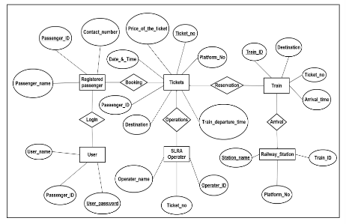

1. **External Interface Requirements**

* 1. **External Interfaces**
* Train Delay Alert Service
* Booking Terminals
* Interactive voice Response System
* Touch Screen
* Passengers operated Enquiry Terminals.

* 1. **User Interfaces**
* **Employee :** An employee can only view the login interface and after login to the system he can just view the front page where it can enter some record, delete it, shift it to some other place and logout after a certain time.
* **Passenger** : It doesn’t have any direct link with the system. It just can browse the web browser for online booking facility. There we had to record its information and then he/she will view the configuration page having a message.
* **Administrator :** It can view various reports that is :
* Total income a particular journey has made.
* Total numbers of seats are reserved in a particular journey
* Number of trains arrival and depart per day.
* **System Actor :** This is a system actor that provides the whole schedule to the original system it just can update the system according to its need, Online booking is also handled by it provides a complete interface to passengers for online booking**.**
  1. **Hardware Interfaces :**

The major hardware component is the regular PC which communicates with the server. The server then communicates with the database. The protocol involved between the PC's and the server is the HTTP protocol, which allows communication between the PC's and the Server.

**4.4 Software Interfaces :**

The database engine can be embedded on a platform using:

* An active mySQL server
* A browser which acts as a client
* An Apache HTTP server

The Apache server between the client and the database will handle all communication, and the server will run on a Linux operating system. This will be provided and handled by the domain name provider. For database handling a DBMS will be required. MySQL will be used for this purpose. The online component consists of an Internet based calendar, where interaction occurs through a web browser. The web interface should support at least Mozilla Firefox 2.0 and greater, Internet Explorer 6.0 and greater, Google Chrome 4.0 and greater and Opera 9.0 and greater.

* 1. **Communications Interfaces**

There is a LAN used for communication among the different client systems to be used.

1. **The Nonfunctional Requirements**
   1. **Performance Requirements**

* All the view data functions should execute within one second.
* All the update, delete and add functions should execute within one second.
* At least 500 users should be able to login to the website at once.
  1. **Safety Requirements**
* System should be able to recover from crash
  1. **Security Requirements**
* Each and every user has to log in to the system using a Username and a Password and should thereby prove their identity.
* An encryption method will be used when storing the passwords in the database and therefore even if the database is hacked the passwords would be kept safe.
* Only the super admin will have full access and privileges to the system.
* The user information will never be sold to other parties and will be kept secure at all times.
* Users will be authenticated to ensure that no unauthorized users gain access to private information.

**5.4 Software Quality Attributes**

* **Adaptability :** The system is adapted to the current manual system that the company is using.
* **Availability :** The system is available in 24 hours daily. The Administrator can access all data in database at any time. Other users can access to the data according to their privileges. System needs 5-10 min of down time once a week for database backup purposes.
* **Correctness :** The correctness of the system should be at least 85% when taking the assumptions and the constraints together.

1. **Other Requirements:**

Illegal accesses and illegal data manipulation not allowed in this system and all the manipulations are under supervision of the Administrator. The Administrator has the full access to the any subsystem. The reports can be generated at any time due to business requirements.

**Ques : 3**

Categorize the requirements

**Normal requirements**

* Registering User
* Updating Information
* Information validation
* Generating e-ticket
* Authentication of User
* Administration Control
* View Previous Details
* Search Bus
* Time Schedule for Different Routes
* Online Payment
* Generating Bill
* Ticket Cancellation
* Booking Confirmation and Seat Reservation

**Expected Requirements**

* The system shall provide attractive graphical interface for the user.
* The system shall allow developer access to installed environment.
* The system shall target customer base.

**Exciting requirements:**

* Reliability: The application should be reliable and it should generate all updated information in correct order.
* Availability: Application will be available and working properly for all the time (24 hours)

**Lab Exercise 2:**

**Ques 1 :** Use Case diagram for an email-based website

This Use Case Diagram is a graphic depiction of the interactions among the elements of Mailing System. It represents the methodology used in system analysis to identify, clarify, and organize system requirements of mailing System.

The main actors of mailing System in this Use Case Diagram are:- Super Admin, System user, Users, Anonymous Users, who perform the different type of use cases.

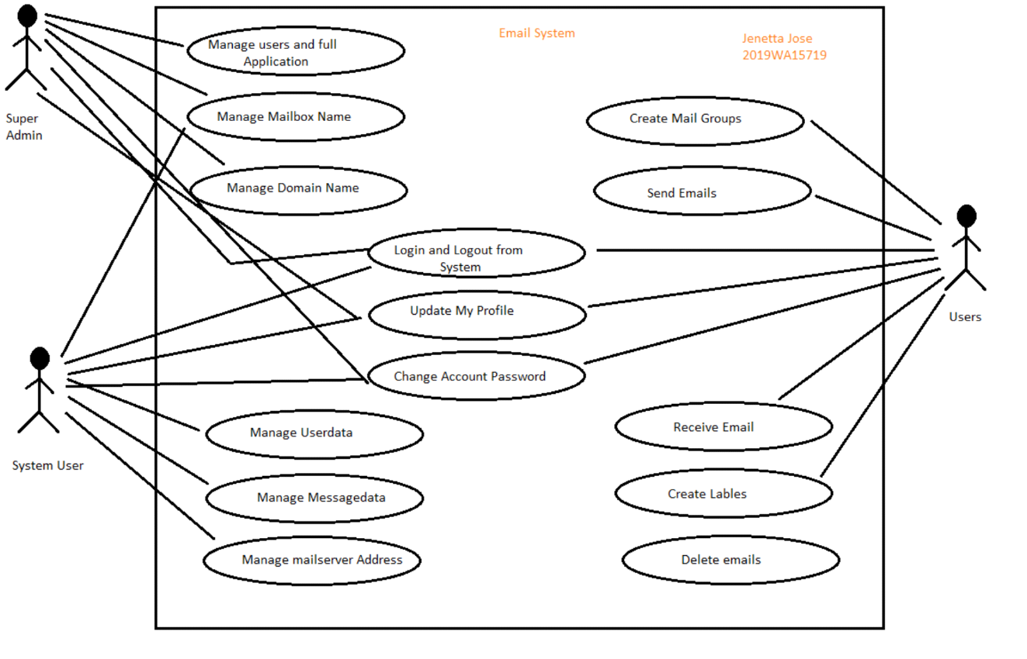

Use Case diagram for an email-based website

**Ques 2 :** Use Case diagram for eLearn portal of BITS

This Use Case Diagram is a graphic depiction of the interactions among the elements of e-Learn BITS portal. It represents the methodology used in system analysis to identify, clarify and organize system requirements of e-Learn portal. The main actors of portal in this Use Case Diagram are :Admin, System User, teacher, Student who perform the different type of use cases such as Manage Course, manage Students, manage Schedules, Manage Durations, Manage Training, manage Subject, Manage Users and Full e-LEARN portal Operations.

Use Case Diagram of BITS portal **after logging to the portal.**

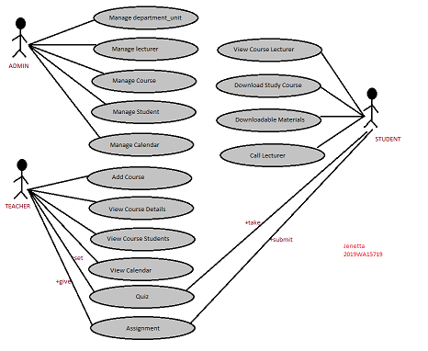

Use Case diagram for eLearn portal of BITS

**Ques 3 :** Use Case diagram for Online Railway Reservation

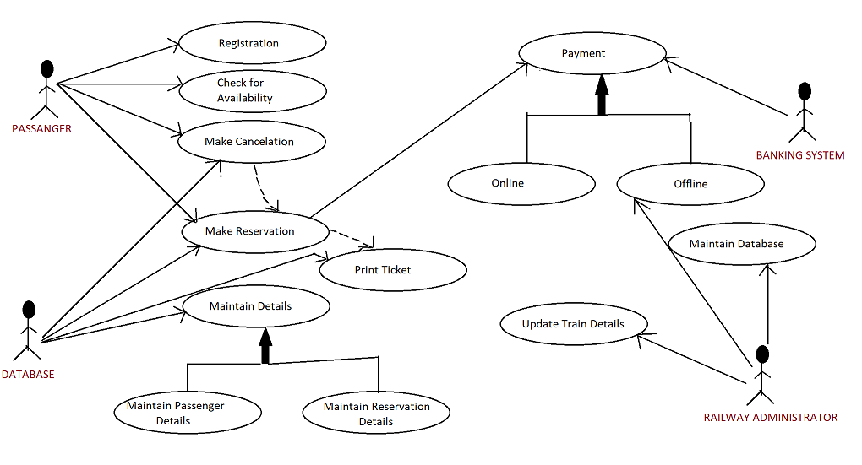

Use Case diagram for Online Railway Reservation

**Use-Case text Scenario for Reservation ( Online Railway Reservation )**

|  |  |
| --- | --- |
| **Use-case:** | Reservation |
|  | |
| **Primary actor:** | Passenger/User |
|  | |
| **Goal in context:** | To book the ticket via online website |
|  | |
| **Preconditions:** | Passenger must register and log in to the online railway reservation system. |
|  | |
| **Trigger:** | The passenger wants to travel in train. |
|  | |
| **Scenario:** | |
| 1. Passenger logs in to the online website. | |
| 1. Passenger selects train, date to travel. | |
| 1. Passenger chooses the payment method that pay a ticket cost. | |
| 1. System confirms the booking and sends a booking number to the customer. | |
|  | |
| **Exceptions:** | |
| 1. If username and password are invalid, system must ask username and password to retry to log in system. | |
| 1. Unavailable seats or berths. No availability of train to current location. | |
| 1. If the entered data is right, the system proceeds for the next step. | |
|  | |
| **Priority:** | High Priority |
|  | |
| **When available:** | First increment. |
|  | |
| **Frequency of use:** | Every day |
|  | |
| **Channel to actor:** | PC-browser and mobile application |
|  | |
| **Secondary actors:** | Administrator |
|  | |
| **Channels to secondary actors:** | PC-browser and mobile application |
|  | |
| **Open issues:** | |
| 1. The security system from other users. | |
| 1. Will system respond via internet be acceptable given the bandwidth requirement | |

**Lab Exercise 4**

**Ques1**

DFD is the abbreviation for Data Flow Diagram. The flow of data of a system or a process is represented by DFD. It also gives insight into the inputs and outputs of each entity and the process itself. DFD does not have control flow and no loops or decision rules are present. Specific operations depending on the type of data can be explained by a flowchart. Data Flow Diagram can be represented in several ways. The DFD belongs to structured-analysis modeling tools. Data Flow diagrams are very popular because they help us to visualize the major steps and data involved in software-system processes.

**DFD (Level 0) for the email-based website**

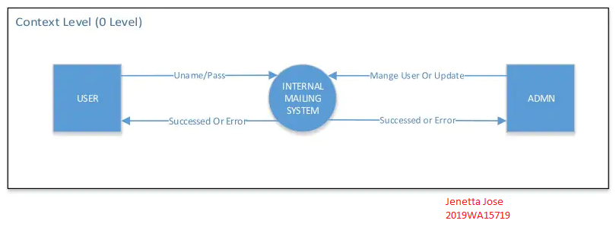

**DFD (Level 1) for the email-based website**

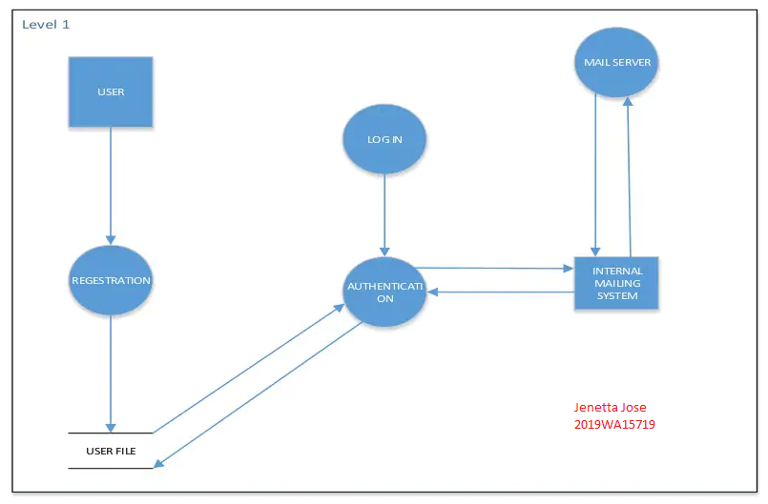

**DFD (Level 2) for the email-based website**

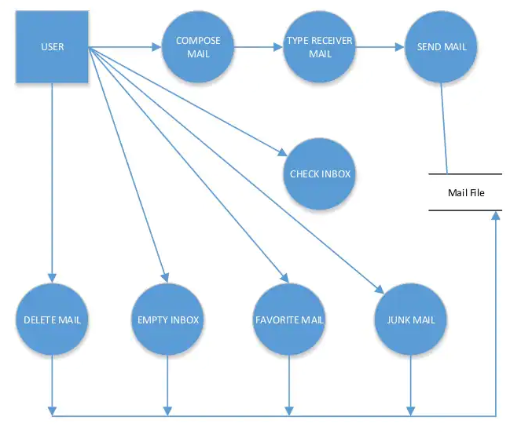

**Ques2**

A data flow diagram can dive into progressively more detail by using levels and layers, zeroing in on a particular piece. DFD levels are numbered 0, 1 or 2, and occasionally go to even Level 3 or beyond. The necessary level of detail depends on the scope of what you are trying to accomplish.

* **DFD Level 0** is also called a Context Diagram. It’s a basic overview of the whole system or process being analyzed or modeled. It’s designed to be an at-a-glance view, showing the system as a single high-level process, with its relationship to external entities. It should be easily understood by a wide audience, including stakeholders, business analysts, data analysts and developers.
* **DFD Level 1** provides a more detailed breakout of pieces of the Context Level Diagram. You will highlight the main functions carried out by the system, as you break down the high-level process of the Context Diagram into its subprocesses.
* **DFD Level 2** then goes one step deeper into parts of Level 1. It may require more text to reach the necessary level of detail about the system’s functioning.

**DFD (Level 0) for the eLearn portal of BITS**

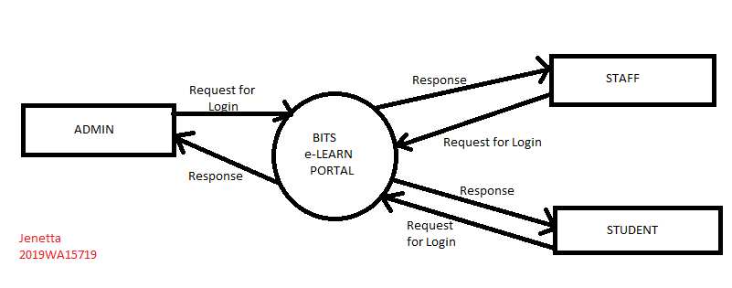

**DFD (Level 1) for the eLearn portal of BITS**

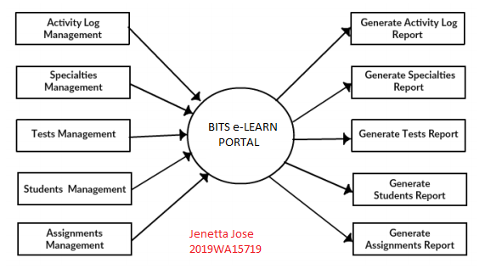

**DFD (Level 2) for the eLearn portal of BITS**

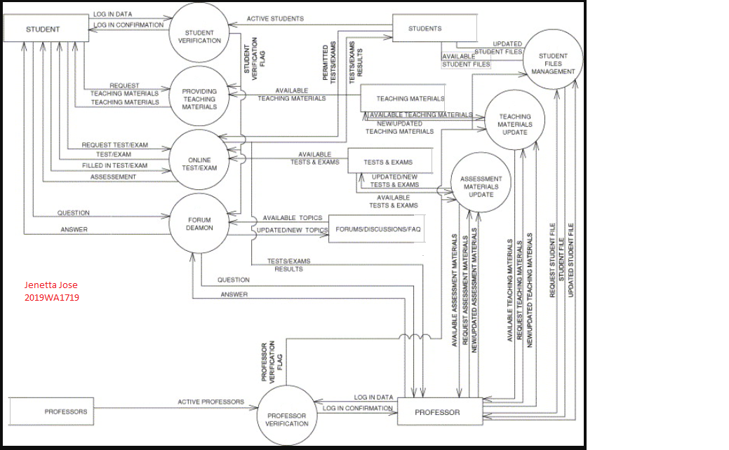

**Ques3**

**DFD (Level 0) for Online Railway Reservation**

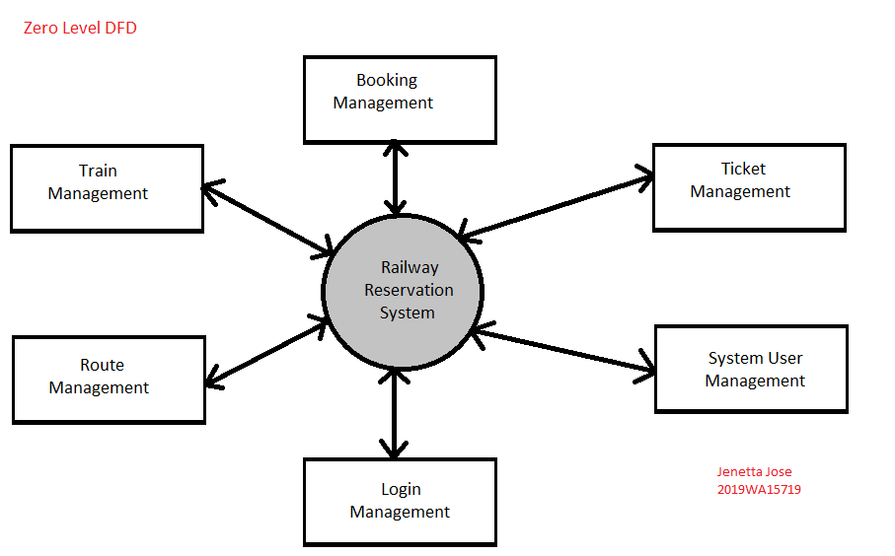

**DFD (Level 1) for Online Railway Reservation**

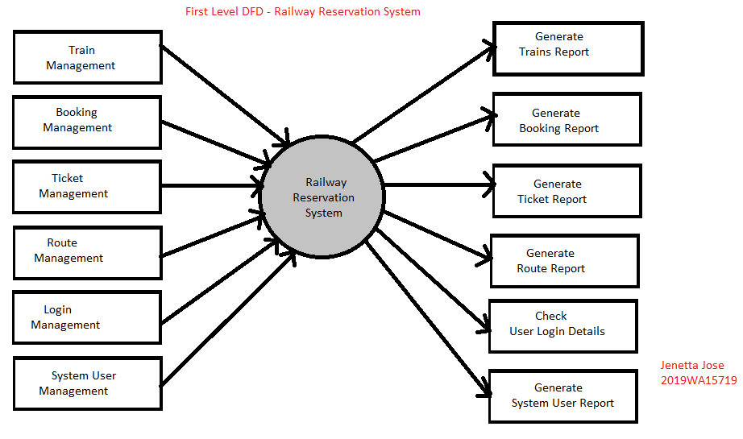

**DFD (Level 2) for Online Railway Reservation**

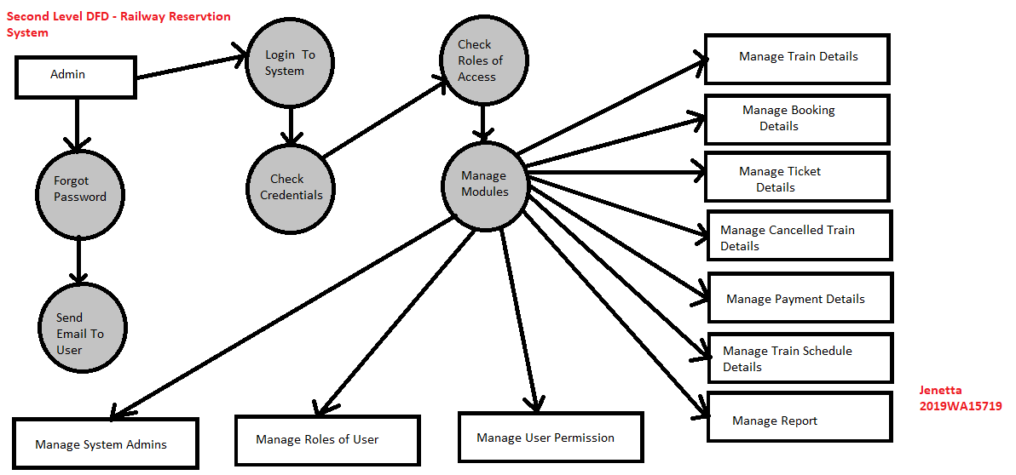

**Lab Exercise : 5**

**Ques1**

**email-based website:**

--------------------------

Abstract : A data distribution system Email system servers as a server computer for transmitting email files to a computer network for access by remote computers having email client computer software for displaying the email files. This is a secure method and system for administering to software on a plurality of client computers is disclosed.

In Email System Client Server there will be two users.

The following are the users process diagrams:

1. Email-server

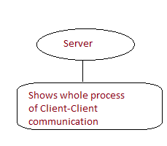

**Server** will establish the connection between client-client communications.

1. Email-client

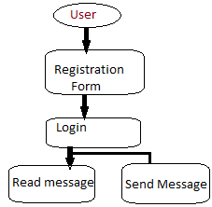

The email system it contains two sub systems:

1. the user agents are used to read, send, compose, replies to messages, display incoming messages, and arrange messages by filing, searching, and deleting them. Examples to most common user agents are Google Gmail, Microsoft Outlook, Mozilla and Apple Mail.
2. The message transfer agents, are used to send messages from the source to the destination with the help of Simple Mail Transfer Protocol (SMTP). They are also known as mail servers.

**CLASS DIAGRAM OF EMAIL WEBSITE**

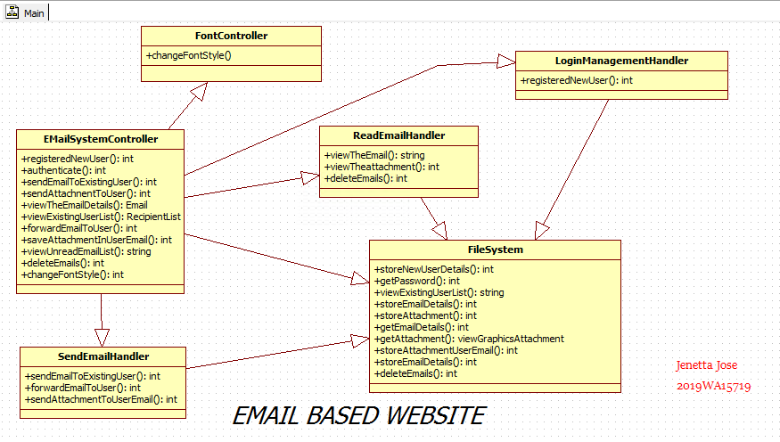

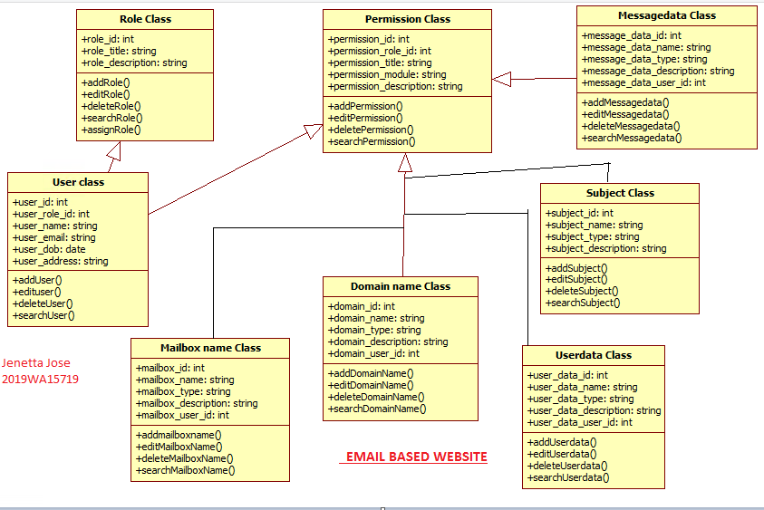

**Ques2**

**Class Diagram of eLearn portal of BITS**

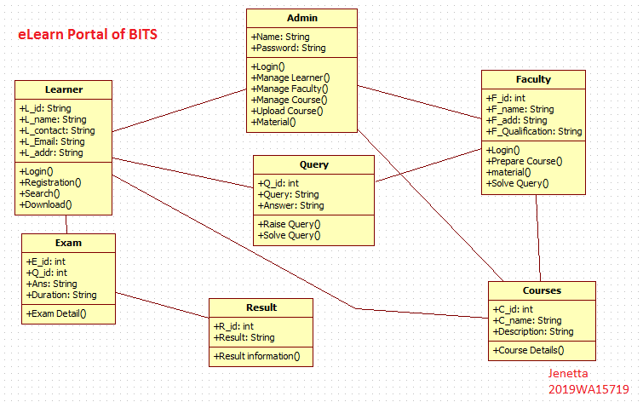

**Ques3**

**Class Diagram of Online Railway Reservation**

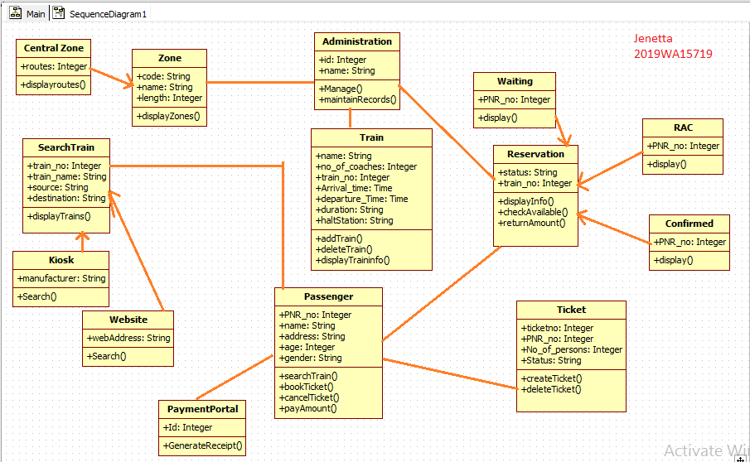

**Lab Exercise 6:**

**Ques1**

**(a) State Chart Diagram for Online Reservation System**

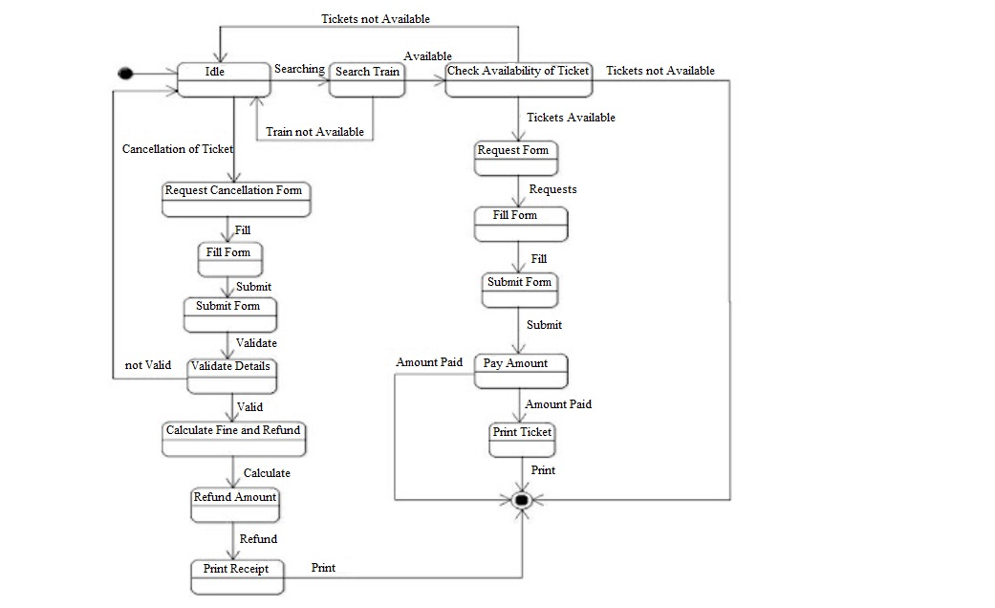

**(b)Deployment Diagram for Railway Reservation**

A deployment diagram is a diagram that shows the configuration of run time processing nodes and the components that live on them. Deployment diagrams is a kind of structure diagram used in modelling the physical aspects of an object-oriented system. They are often be used to model the static deployment view of a system.

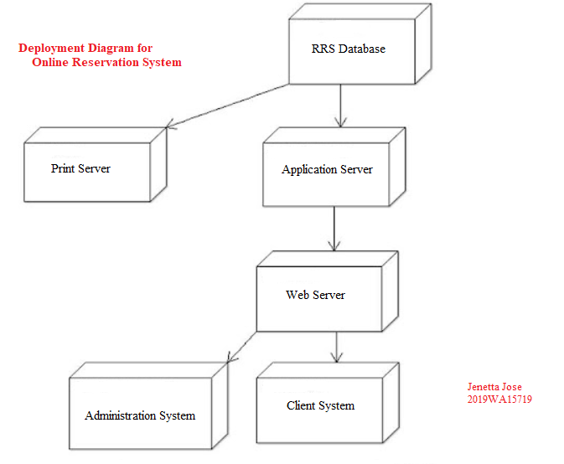

**Component Diagram for Railway Reservation**

Component diagrams are used in modeling the physical aspects of object-oriented systems that are used for visualizing, specifying, and documenting component-based systems and also for constructing executable systems through forward and reverse engineering. Component diagrams are essentially class diagrams that focus on a system's components that often used to model the static implementation view of a system.

